Project:
Project Working Title: Simulating the Brownian Dynamics of a Two-Dimensional Model for the Dynein Motor Protein

Project End Date: 10 May 2019 (The end of week 6 of spring term)

Student:
Name: John L. Waczak
Affiliation: Department of Physics, Oregon State University

Biography: I am a senior physics and mathematics major at Oregon State University. My interests include computational and theoretical physics. Currently, I am studying a two dimensional rigid-rod model for the motion of the dynein motor protein. This summer, I worked at the Harvard Smithsonian Center for Astrophysics under an NSF REU grant where I modeled the ionization of coronal plasma in coronal mass ejection (CME) shock waves. I will be presenting my work this December at the AGU Fall Meeting in Washington DC.

Statement: I will work regularly and diligently on this project throughout the year and initiate meetings with my advisor to seek feedback and guidance on the research. I understand that a significant portion of the research should be completed by the end of winter term to enable me focus on the writing process in the PH403 class.

Student Signature: _____________________________

Advisor:
Name Dr. David Roundy,
Affiliation Department of Physics, Oregon State University

I have read this thesis proposal. I agree that the scope is reasonable for completion by May 10, 2019 and that sufficient progress can be made by early winter term 2019 to allow significant revision of the thesis during the winter and spring terms of 2019.

Advisor Signature: _____________________________

Project Summary
While the chemical cycle for the stepping behavior of the dynein motor protein is an active area of research, there is no widely accepted model explaining its dynamic motion . In this research thesis, I will investigate a two-dimensional model for the motion of dynein as a drunken-walker. The model identifies dynein as a system of domains held together by rigid rods. These domains are guided towards an equilibrium configuration by Hooke’s law restorative torques as they are bombarded by external, random Brownian forces. We believe that this combination of diffusion and a preferred configuration is sufficient to reproduce dynein’s unique stepping behaviors. Dynein is crucial to many cellular processes and understanding how it moves is important in the discussion of why multiple types of motor proteins have co-evolved as well as what conditions cause the motor to malfunction.
I will be continuing previous work with Elliott Capek and Dr. David Roundy on a C++ simulation of this model. My goal is to establish a set of parameters that demonstrate this model’s feasibility by replicating various stepping statistics such as step lengths, leading-trailing step fractions, binding and unbinding time, etc… Having identified such a set of parameters, I will then investigate the ability of the model to respond to additional external forces such as those due to pulling cargo through the cell. If time permits, I also would like to explore how the equilibrium angles in our model lead to directed motion. This may help shed light on why dynein is a minus-end directed motor protein.

Project Description
Introduction
The dynein motor protein is a unique molecule among the family of motor proteins. Unrelated to similar motors of the kinesin family, dynein consists of heavy chains which include a large motor domain [1]. This large size means that the protein is constantly being bombarded by water molecules which impart random pushes to the protein. The resulting kinematics are called Brownian dynamics and the subsequent motion of dynein has been dubbed “drunken-walking” due its tendency to take steps forward, backwards, diagonally, and in no particular order. The many forms of dynein play critical roles in everything from cell division to the movement of flagella. Its occasional mutation can lead to critical cell malfunctions and has even been linked to neurodegenerative diseases [4].
To date, research on the protein has investigated the chemical cycle required for dynein to convert ATP into usable mechanical energy [2]. Other studies have tested the extent to which mechanical information is stored between the legs of the protein, that is, how much previous steps and the steps of opposite legs affect future stepping behavior [3]. Somehow, despite all of this investigation, there is no accepted model that explains the motion of this system as a physical object moving through space. Through direct simulation of the Brownian dynamics on a simplified two-dimensional structure, we propose a physical model for the movement of dynein that can replicate many of its famous behaviors including the drunken walk. Individual domains are allowed to pass through one another to account for the truly 3-dimensional structure. During each time step of the simulation, a random diffusive force is applied to each domain as well as a restorative torque that pushes the domains towards an equilibrium angle.

Plan of work
Initially, my goal is to verify that the simulation is working correctly. We recently a new factor to our binding energies in order to replicate studies that show inter-binding-domain separation is correlated with which leg of dynein steps. In other words, it appears that dynein is more likely to step when its legs are stretched far apart. This will involve writing and running tests to debug the updated simulation until we are sure that it is performing as expected. One of the largest difficulties is in how we transition from the onebound state to the both bound state. As shown in figure 1, there is a complicated triangle geometry that must be satisfied to numerical precision upon transitioning. When it is not satisfied, properties like the triangle inequality are violated leading to the generation of NaN (not a number) values that must be rejected.
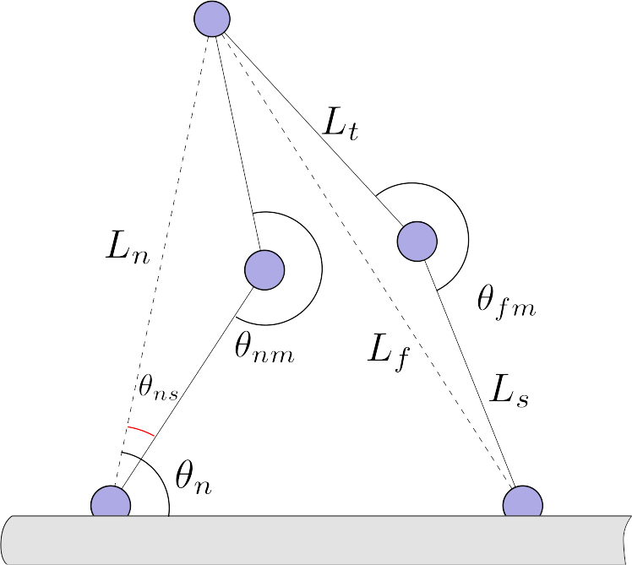Figure 1: Geometry of the Both Bound State
Once we are satisfied with the behavior of the model, I will continue the parameter fitting work previously done by Elliott Capek until we find a set that matches the desired stepping statistics of cytoplasmic dynein such as mean step length, leading vs lagging stepping ratios, binding time, etc… I still need to consult with Dr. Roundy and Elliott regarding a satisfactory list of stepping statistics to try and emulate. This will largely depend on what properties have been examined in real dynein. There is some difficulty here as many researchers test dynein under different conditions; often ATP concentrations are changed which impacts stepping velocities as well as other quantities. Dr. Qiu’s lab does research on motor proteins and I intend to seek his advice regarding this as well. One positive development in this work was Elliott’s realization last spring that it is easy to perform simulations of our model in a single state (one bound or both bound) to greatly increase the speed at which we test certain features like binding probabilities.
Should I finish this work in a reasonable amount of time, I would like to continue testing our model by adding extra external forces to simulate the process of carrying cargo. There are many studies that have explored the possible forces and torques that dynein exerts. Continued work should explore how our model behaves whilst pulling objects. I am also curious to see how our choice of equilibrium angles impacts the direction the system walks. Cytoplasmic dynein is minus-end directed meaning that it walks towards the
Timeline
Fall term
October Verify simulation performance, Literature review
November Fit sim. parameters, Literature review, devise new visualizations
December Fit sim. parameters, Lit review, create outline, draft intro/methods
Winter term
January sim. param. fitting, Write code for external forces
February Finish param. fitting, Test external forces
March Test external forces, draft early results
Spring term
April Finishing gather data, finish results + discussion, final drafting

Data management
Data is generated locally on computers in the Roundy Research Group computer cluster. All code is stored in a git repository that is backed up to the internet and linked to my personal computer as well as Dr. Roundy and Elliott. Simulation files are not typically very large but in code have led to large amounts of data being stored by mistake. To fix this, we only output data used to calculate stepping statistics.

Facilities, Equipment and Other Resources
I will primarily be using my personal laptop for writing and developing code. I will run simulations on the Roundy Research Group computer cluster. Other than that, I also plan to use data on real dynein from Dr. Yildiz (gave a colloquium talk on dynein last year) and Dr. Weihong Qiu’s experimental expertise on measuring motor protein properties.

References Cited
[2] M. A. Cianfrocco, M. E. DeSantis, A. E. Leschziner, and S. L. Reck-Peterson, Annu. Rev. Cell Dev. Biol. 31, 83 (2015).

[3] I. Puls, C. Jonnakuty, B. H. LaMonte, E. L. F. Holzbaur, M. Tokito, E. Mann, M. K. Floeter, K. Bidus, D. Drayna, S. J. Oh, R. H. Brown Jr, C. L. Ludlow, and K. H. Fischbeck, Nature Genetics 33, 455 (2003).

[4] F. B. Cleary, M. A. Dewitt, T. Bilyard, Z. M. Htet, V. Belyy, D. D. Chan, A. Y. Chang, and A. Yildiz, Nat Commun 5, 4587 (2014).

[1] B. Alberts, A. Johnson, J. Lewis, M. Raff, K. Roberts, and P. Walter, Molecular Biology of the Cell. 4th Edition (2002).

